App Engine lab

1. Search for app engine

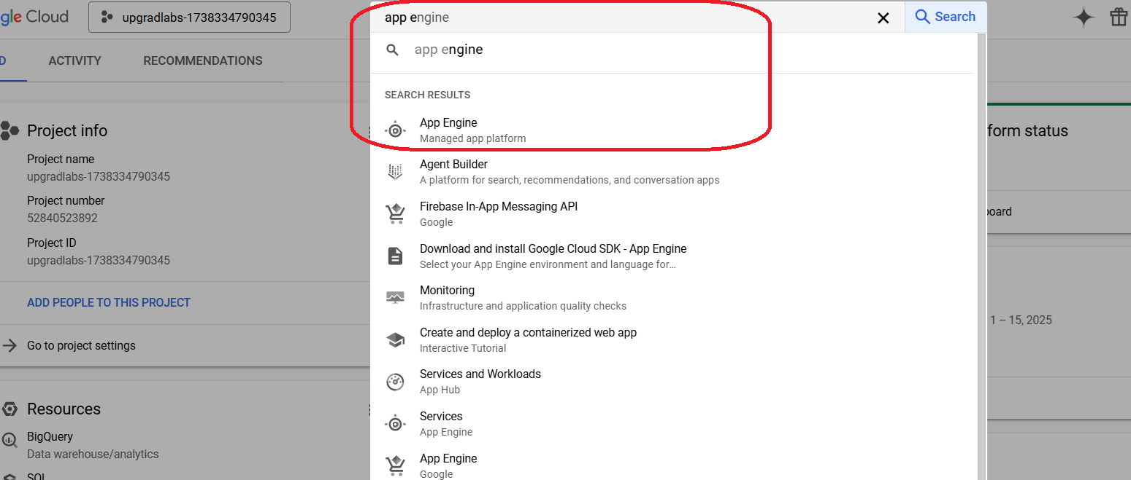

Click on Create Application

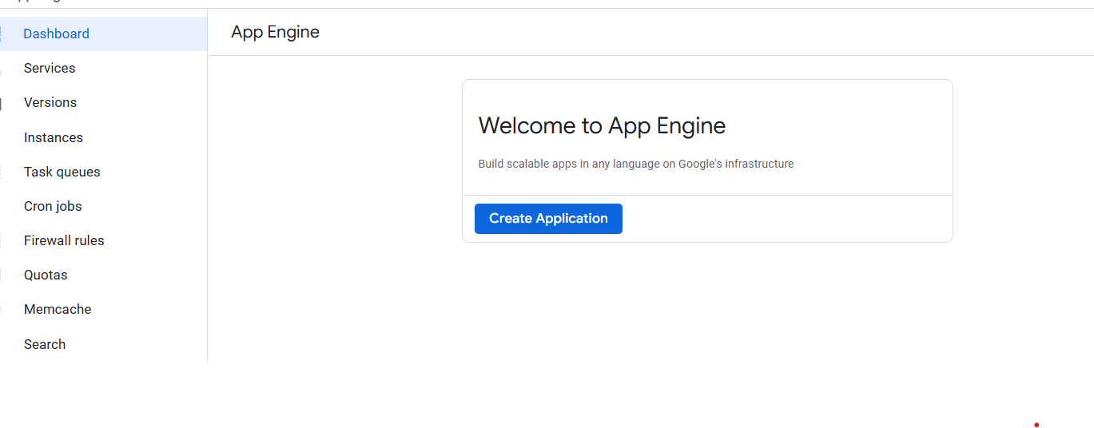

Select the Region

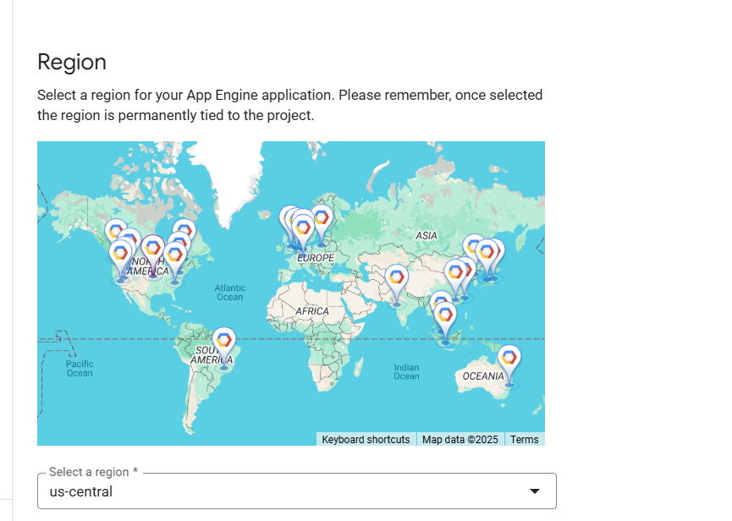

Select the service account and Click Next

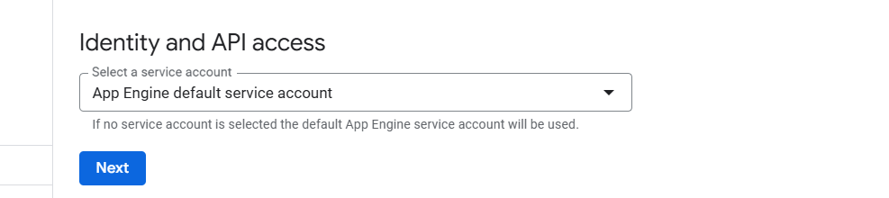

Select the language you want to code

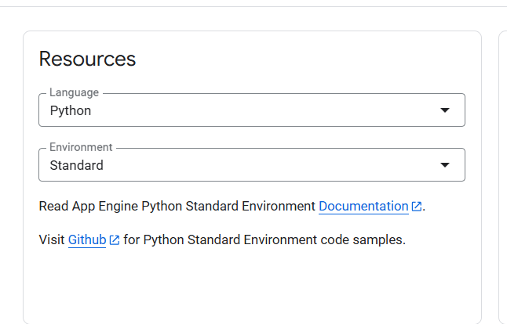

Open the cloudshell

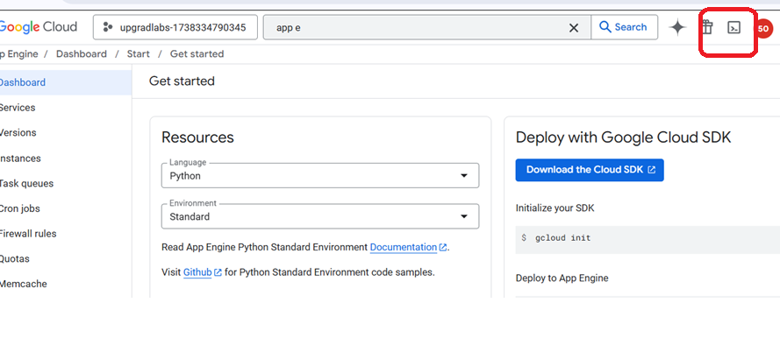

Connect to cloud shell and create these files

main.py

from flask import Flask

app = Flask(__name__)

@app.route('/')

def hello_world():

return 'Hello, World!'

if __name__ == '__main__':

app.run(debug=True, host='0.0.0.0')

requirements.txt

Flask==3.1.0

app.yaml

runtime: python39

Run the command:

gcloud app deploy

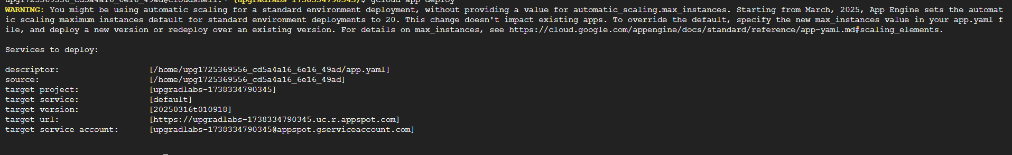

**Press Y to proceed**

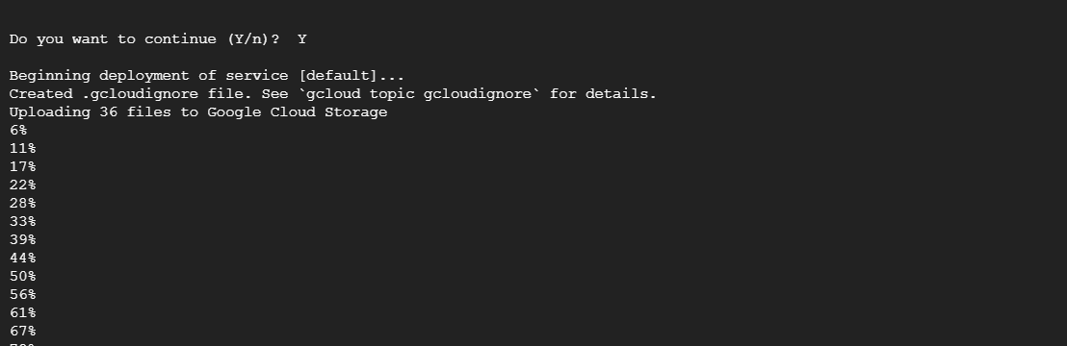

**Click on the link**

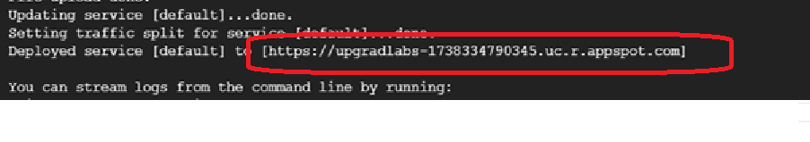

**Go to app engine Dashboard, and click on service**

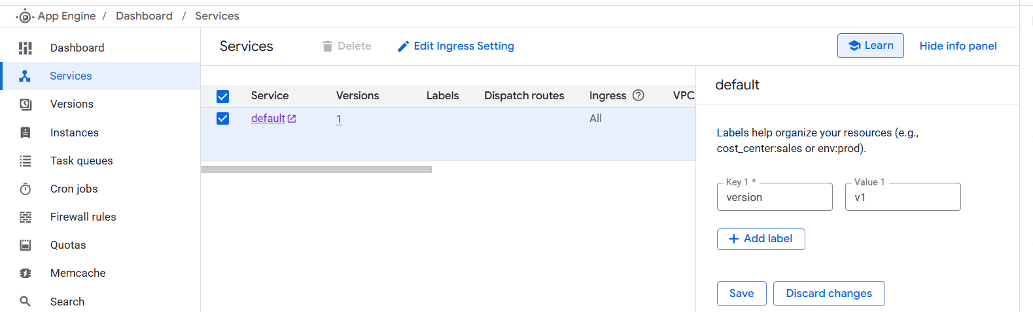

**Provide labels to service**

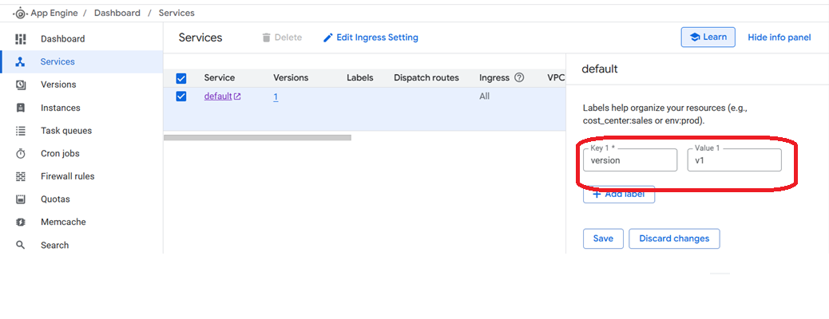

**Let’s edit the fila main.py. This will represent updating the app**

from flask import Flask

app = Flask(__name__)

@app.route('/')

def hello_world():

return 'Hello, to training!'

if __name__ == '__main__':

app.run(debug=True, host='0.0.0.0')

Run the command

gcloud app deploy --no-promote --version 2

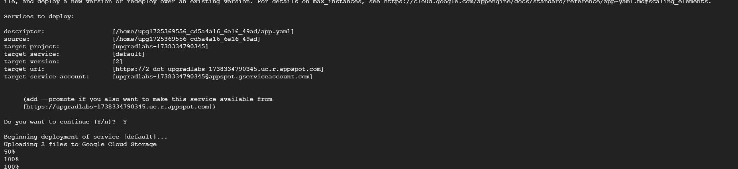

Go to app engine dashboard, and click on version

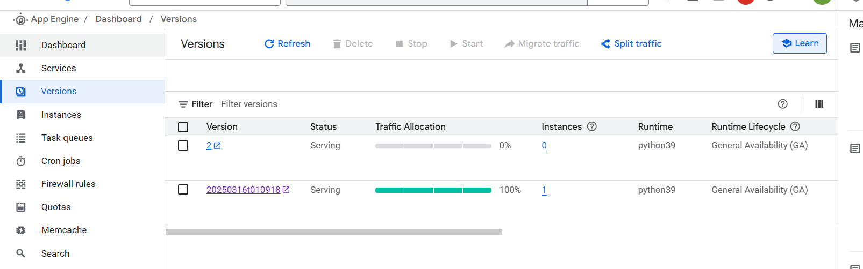

Click on Split traffic

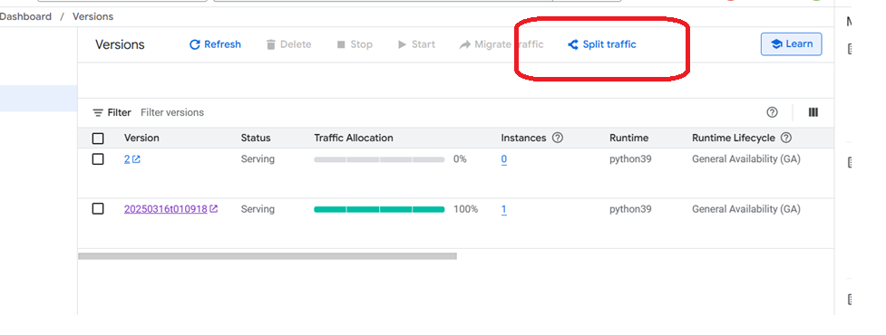

Click on Add version

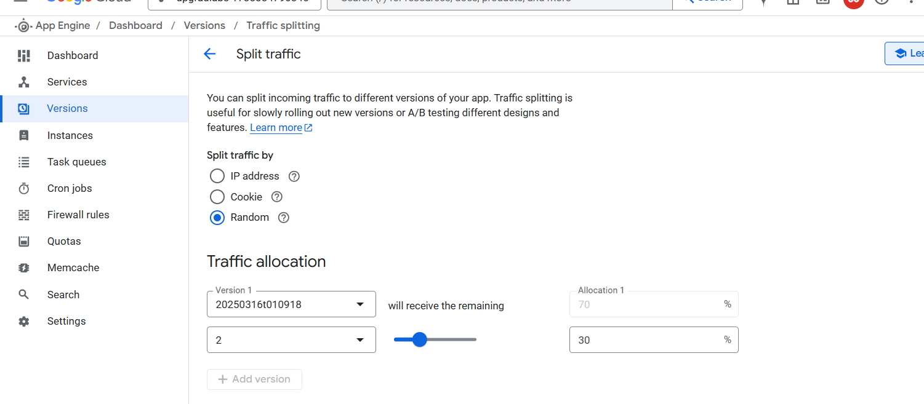

Change the traffic allocation and save it

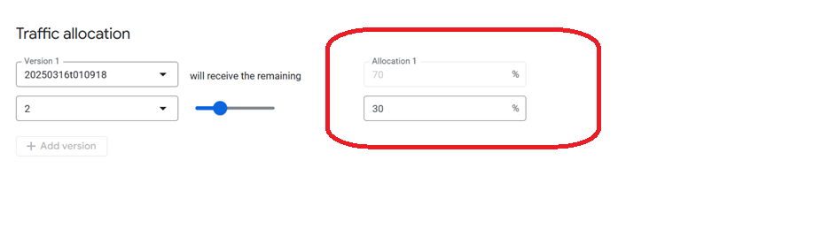

Run the following command to test

gcloud app versions list

gcloud app browse